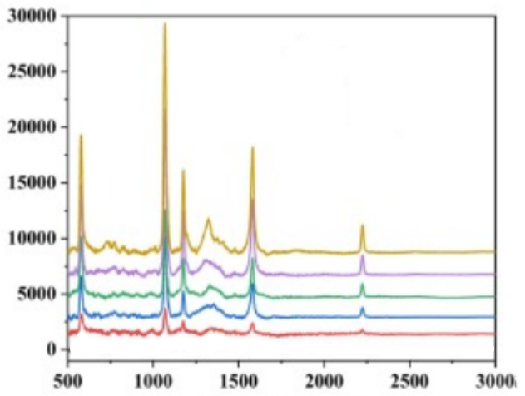

*Figure 1: <https://doi.org/10.1016/j.foodchem.2023.137120>*

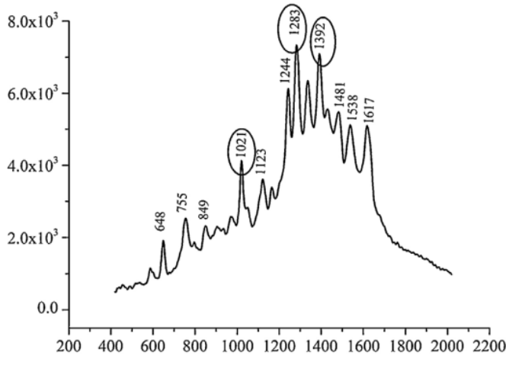

*Figure 2:https://doi.org/10.1016/j.cclet.2015.10.015*

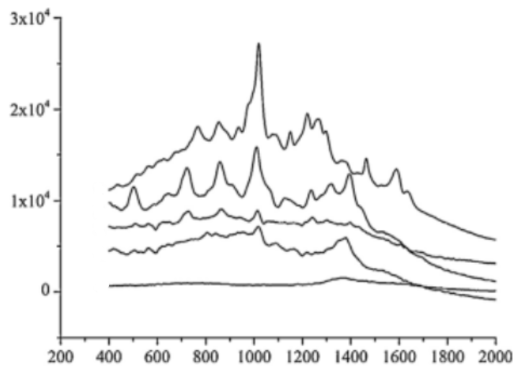

*Figure 3: https://doi.org/10.1016/j.cclet.2015.10.015*

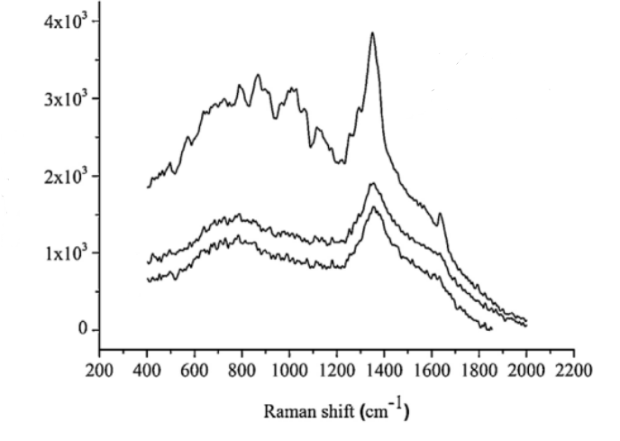

*Figure 4:https://doi.org/10.1016/j.cclet.2015.10.015*

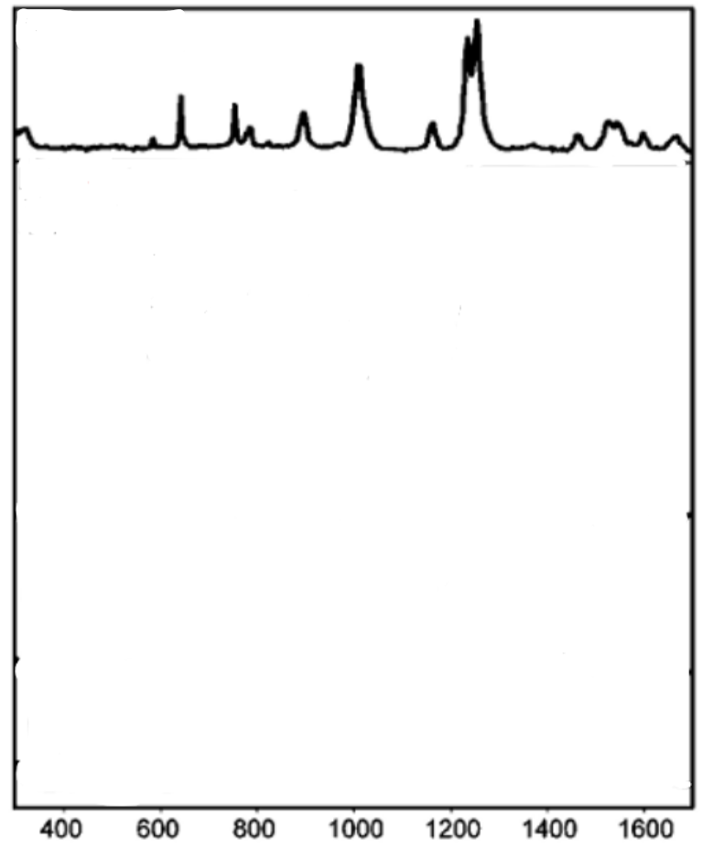

*Figure 5: https://pubs.acs.org/doi/abs/10.1021/ac801626x#*

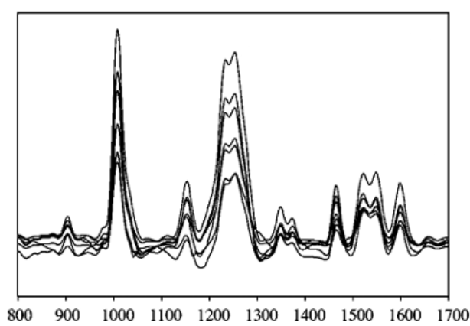

*Figure 6: https://pubs.acs.org/doi/abs/10.1021/ac801626x#*

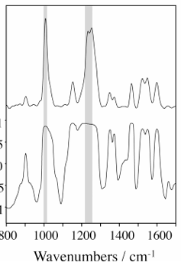

*Figure 7:https://pubs.acs.org/doi/abs/10.1021/ac801626x#*

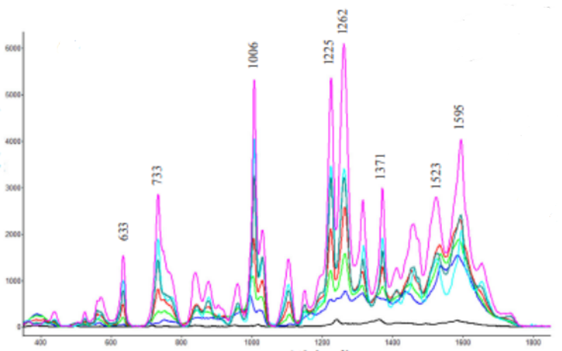

*Figure 8:https://doi.org/10.1016/j.foodchem.2019.04.085*

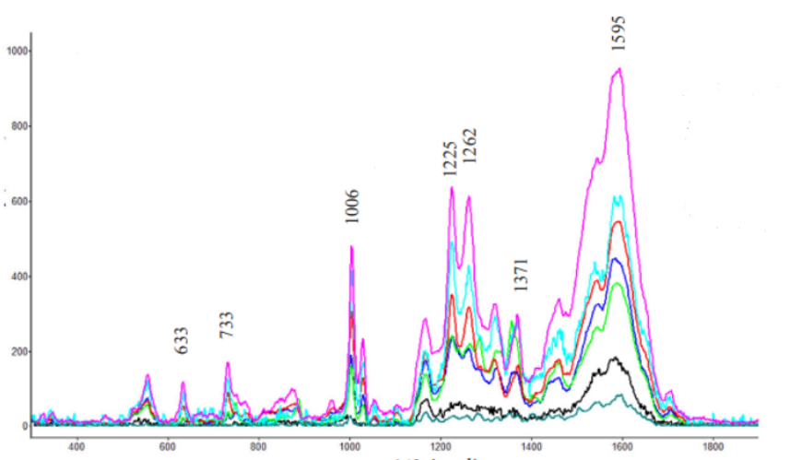

*Figure 9:https://doi.org/10.1016/j.foodchem.2019.04.085*

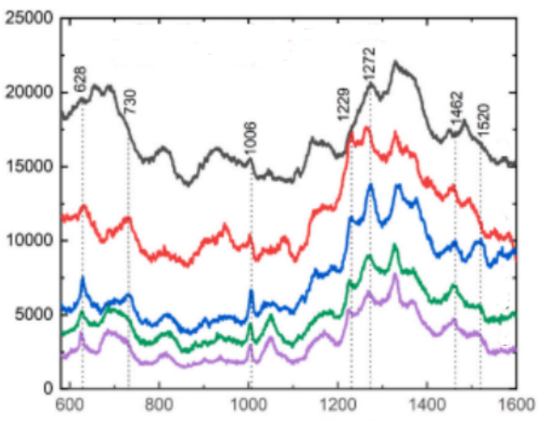

*Figure 10:https://doi.org/10.1016/j.foodchem.2019.04.085*

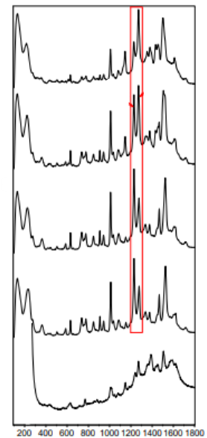

*Figure 11:https://doi.org/10.1016/j.jcis.2015.11.045*

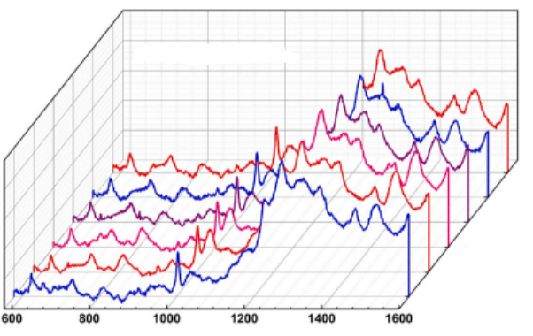

*Figure 12: https://doi.org/10.1016/j.omx.2023.100250*

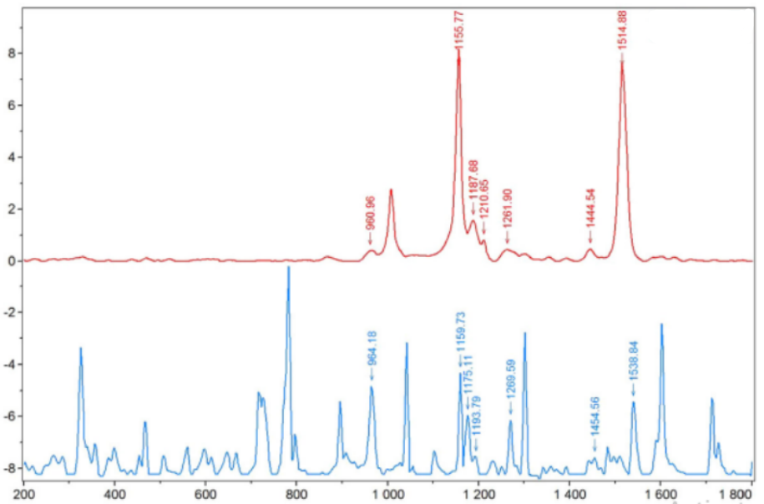

*Figure 13:<https://doi.org/10.1016/j.foodchem.2016.09.051>*

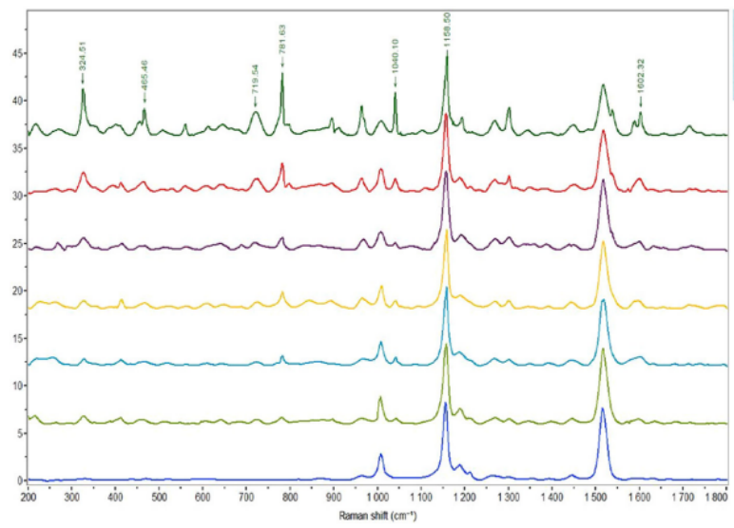

*Figure 14:https://doi.org/10.1016/j.foodchem.2016.09.051*

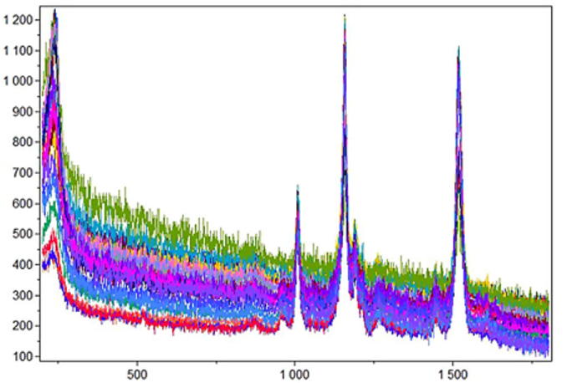

*Figure 15:https://doi.org/10.1016/j.foodchem.2016.09.051*

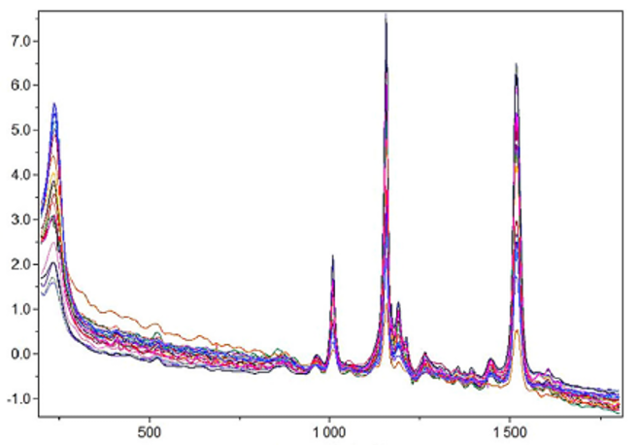

*Figure 16:https://doi.org/10.1016/j.foodchem.2016.09.051*

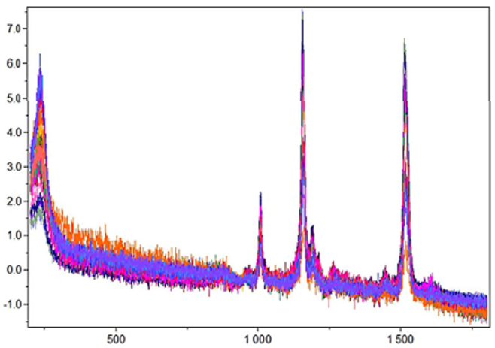

*Figure 17:https://doi.org/10.1016/j.foodchem.2016.09.051*

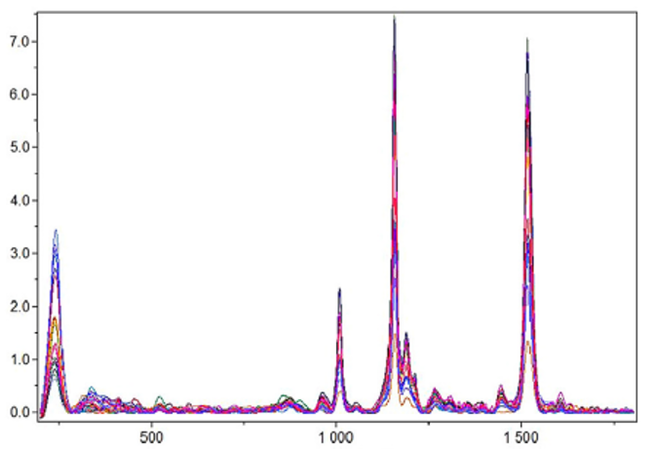

*Figure 18:https://doi.org/10.1016/j.foodchem.2016.09.051*

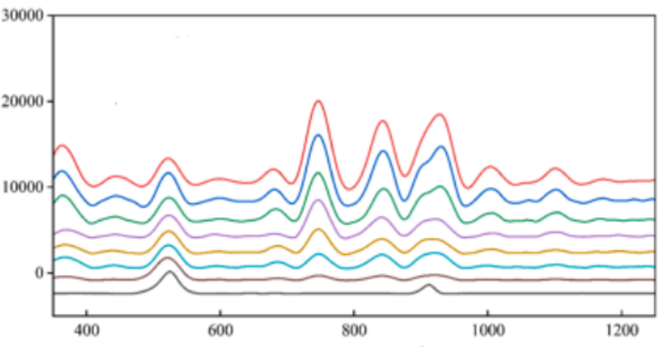

*Figure 19: https://doi.org/10.1016/j.jfca.2025.107293*

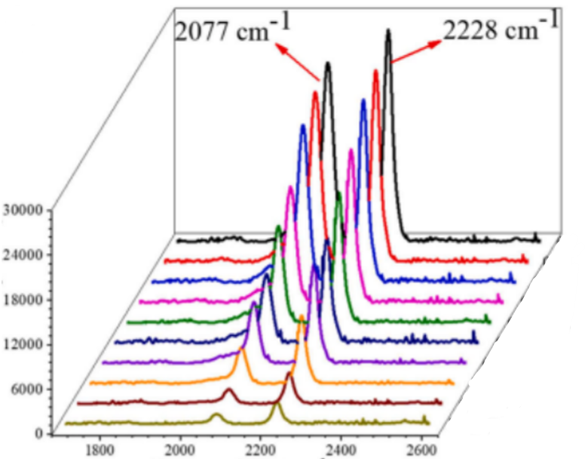

*Figure 20: https://doi.org/10.1016/j.omx.2023.100250*

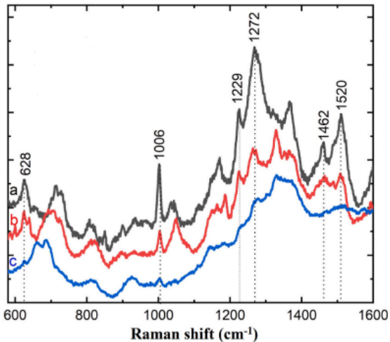

*Figure 21: https://doi.org/10.1016/j.omx.2023.100250*

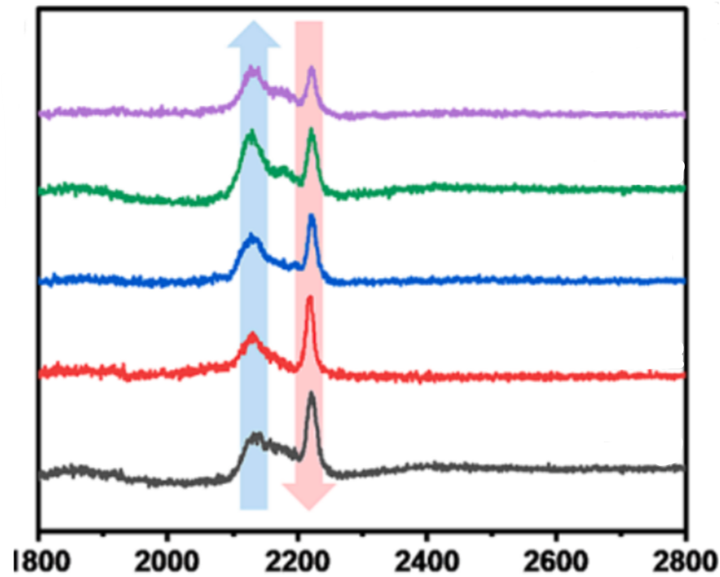

*Figure 23:https://doi.org/10.1016/j.cej.2024.150666*

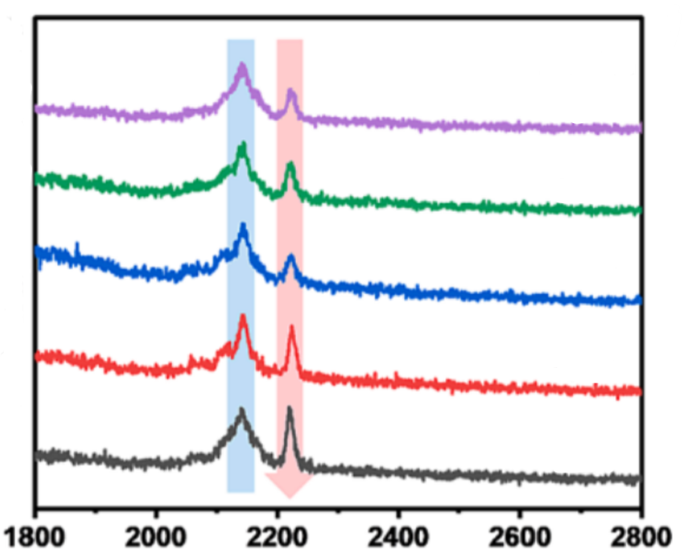

*Figure 24:https://doi.org/10.1016/j.cej.2024.150666*

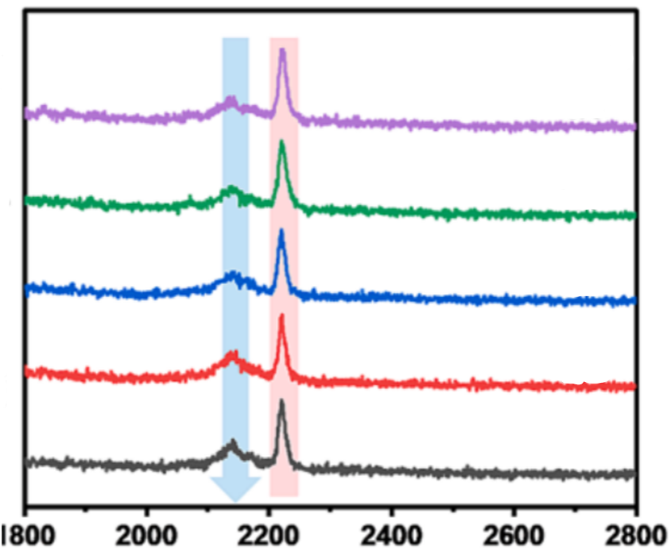

*Figure 25:https://doi.org/10.1016/j.cej.2024.150666*

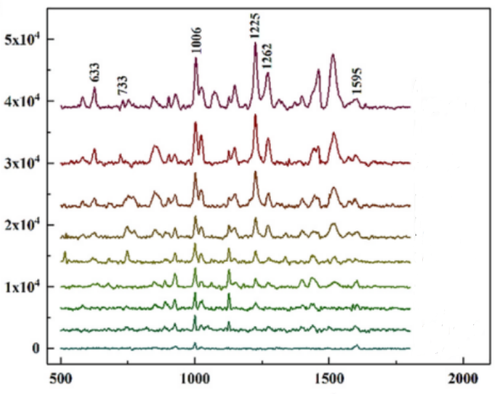

*Figure 26:https://doi.org/10.1016/j.foodchem.2020.128085*

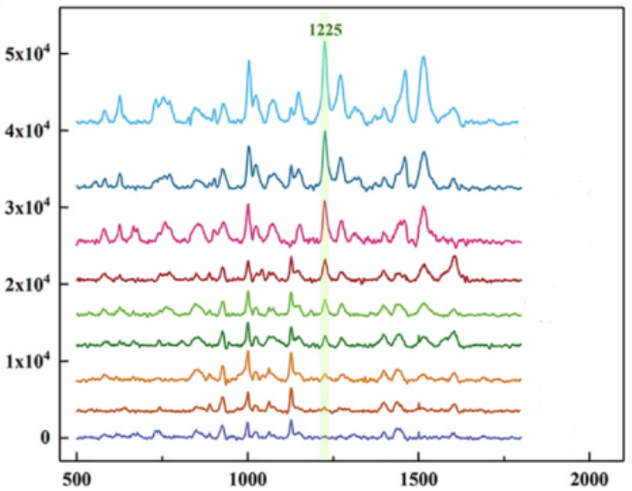

*Figure 27:https://doi.org/10.1016/j.foodchem.2020.128085*

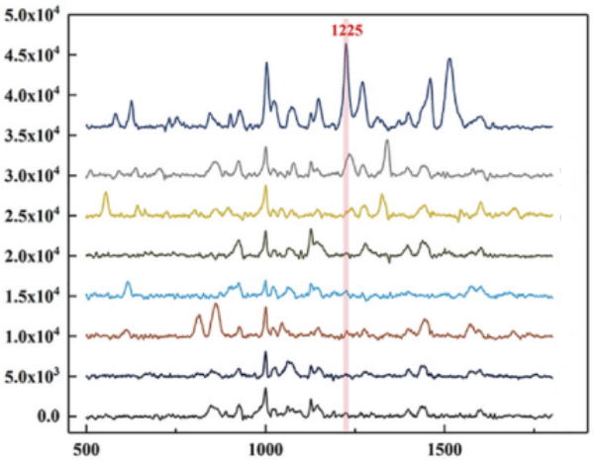

*Figure 28:https://doi.org/10.1016/j.foodchem.2020.128085*

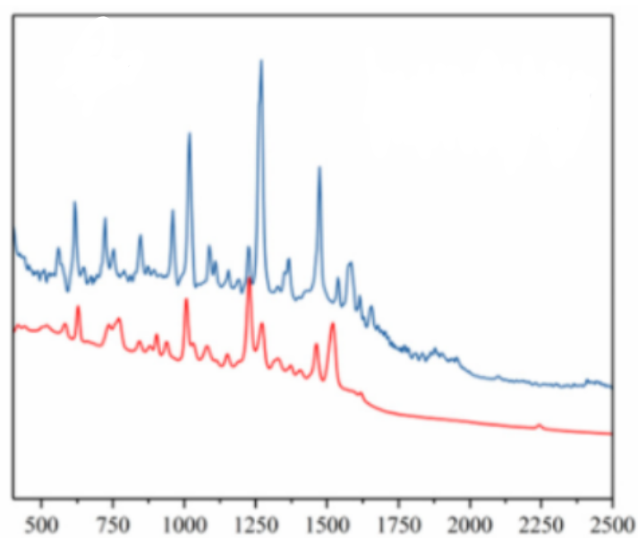

*Figure 29:https://doi.org/10.3390/foods11091287*

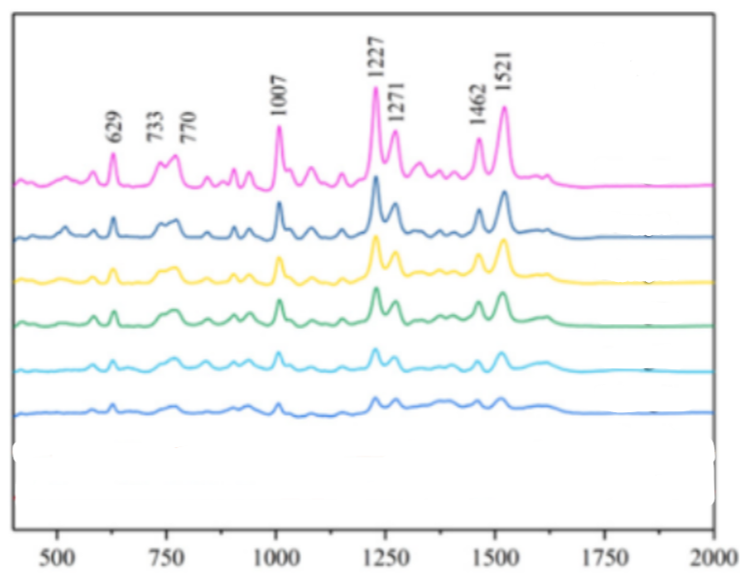

*Figure 30:https://doi.org/10.3390/foods11091287*

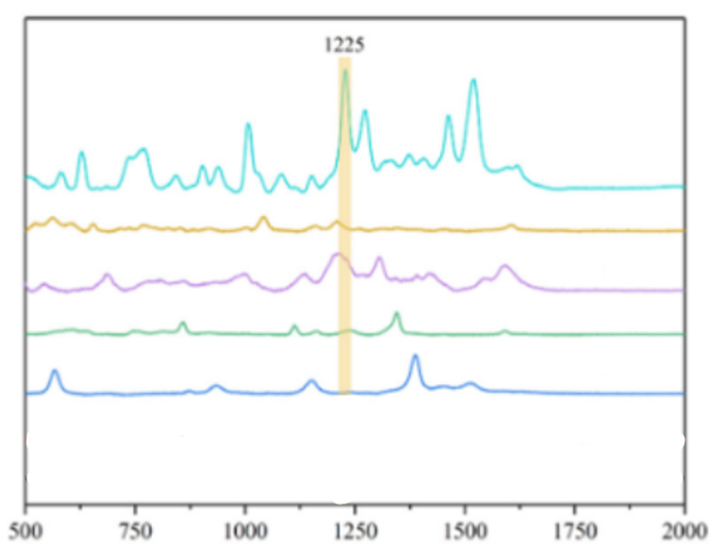

*Figure 31:https://doi.org/10.3390/foods11091287*

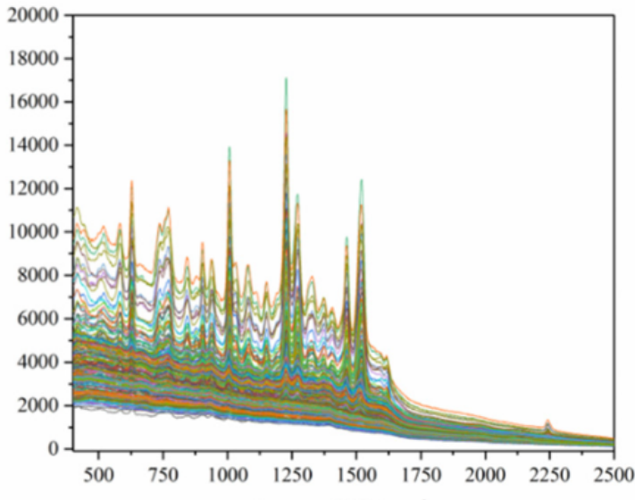

*Figure 33:https://doi.org/10.3390/foods11091287*

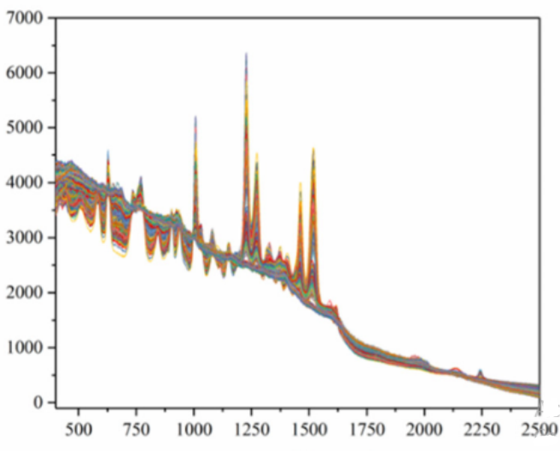

*Figure 34:https://doi.org/10.3390/foods11091287*

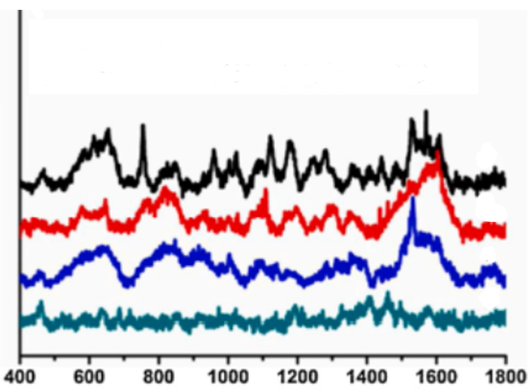

*Figure 35:https://doi.org/10.1016/j.snb.2020.128852*

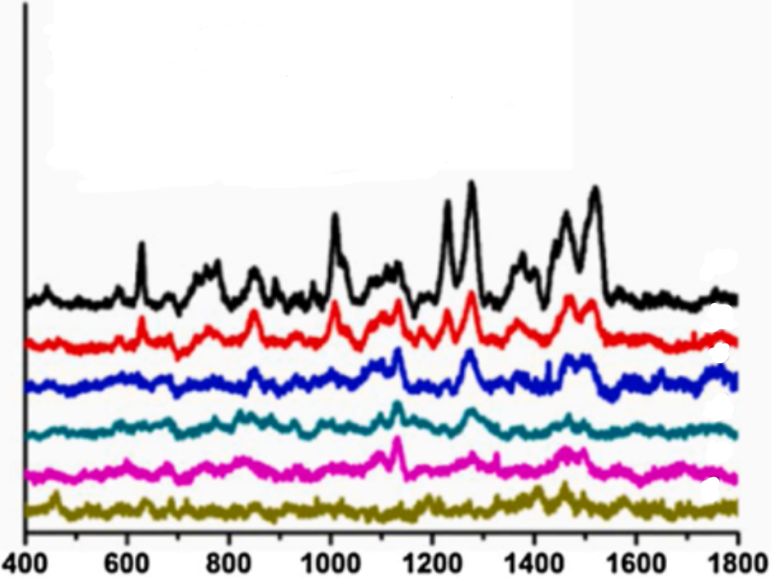

*Figure 36:https://doi.org/10.1016/j.snb.2020.128852*

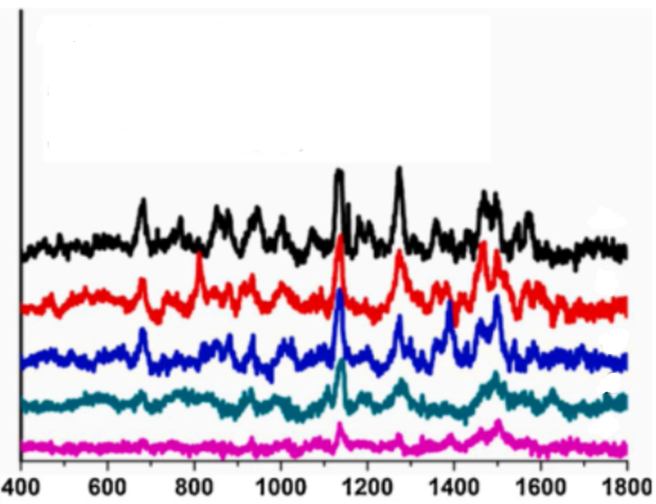

*Figure 37:https://doi.org/10.1016/j.snb.2020.128852*

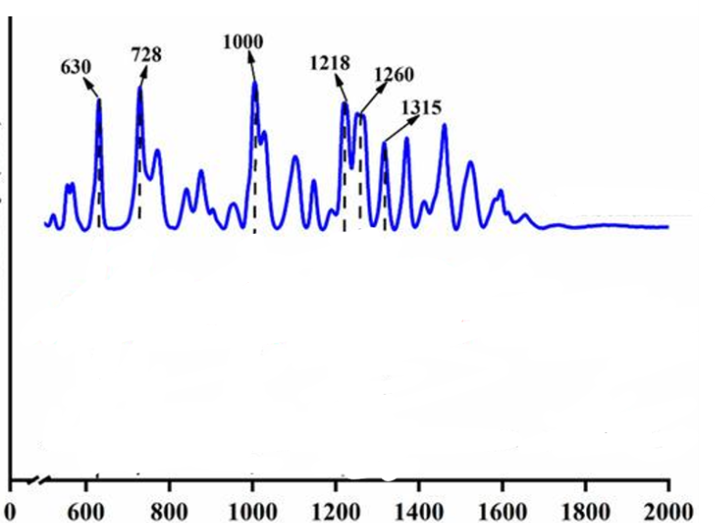

*Figure 38:https://doi.org/10.3390/molecules27134230*

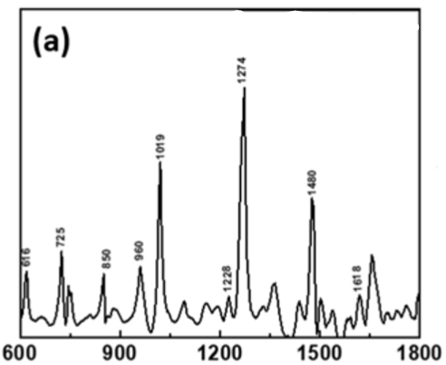

***Figure 39: https://doi.org/10.1016/j.sna.2022.113816***

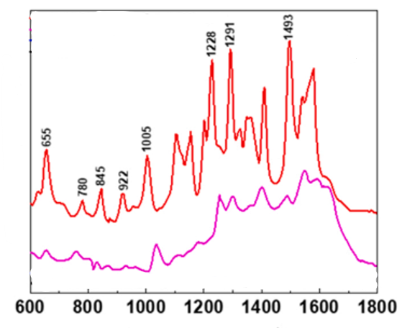

*Figure 40:https://doi.org/10.1016/j.sna.2022.113816*

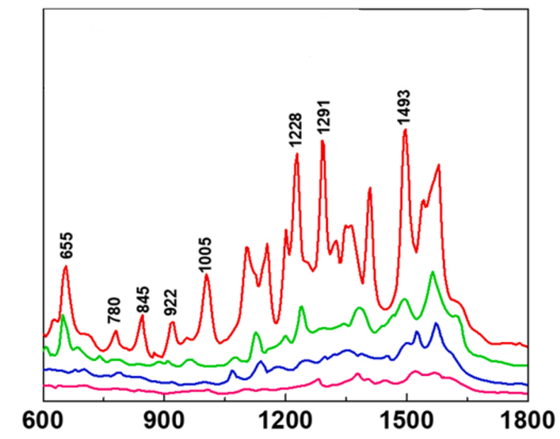

*Figure 41: https://doi.org/10.1016/j.sna.2022.113816*

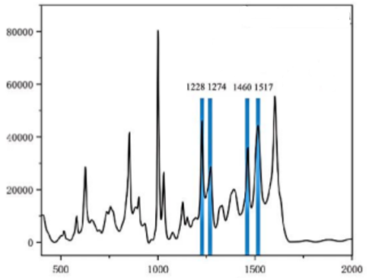

*Figure 42:DOI 10.1088/1742-6596/2873/1/012053*

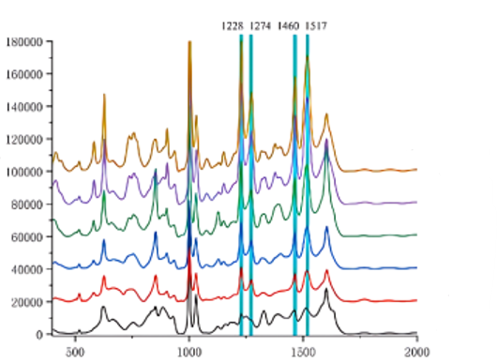

*Figure 43:DOI 10.1088/1742-6596/2873/1/012053*

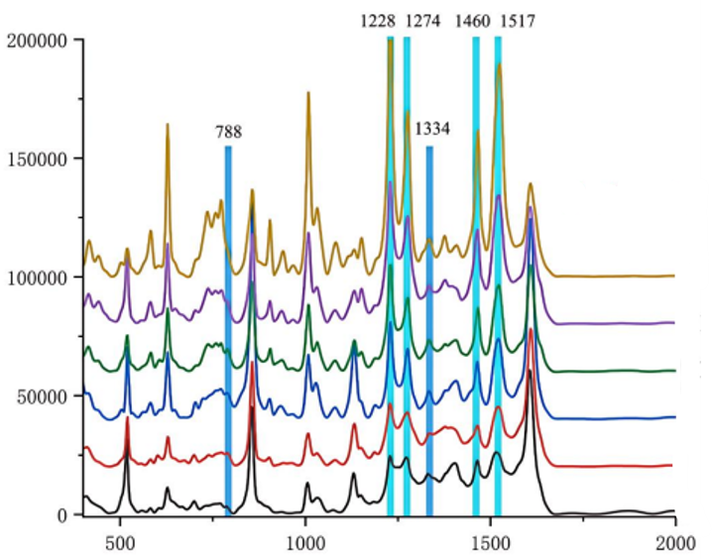

*Figure 44:* ***DOI****10.1088/1742-6596/2873/1/012053*

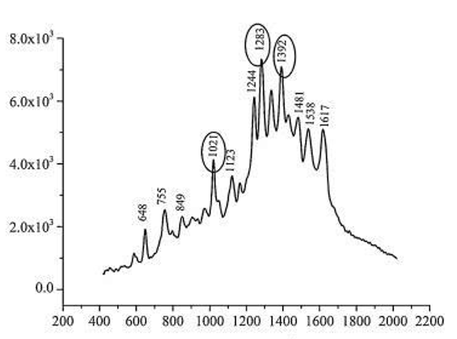

*Figure 45: https://doi.org/10.1016/j.cclet.2015.10.015*

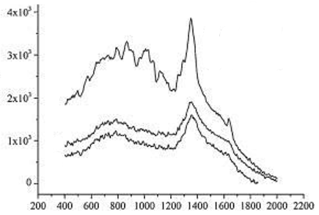

*Figure 46: <https://doi.org/10.1016/j.cclet.2015.10.015>*

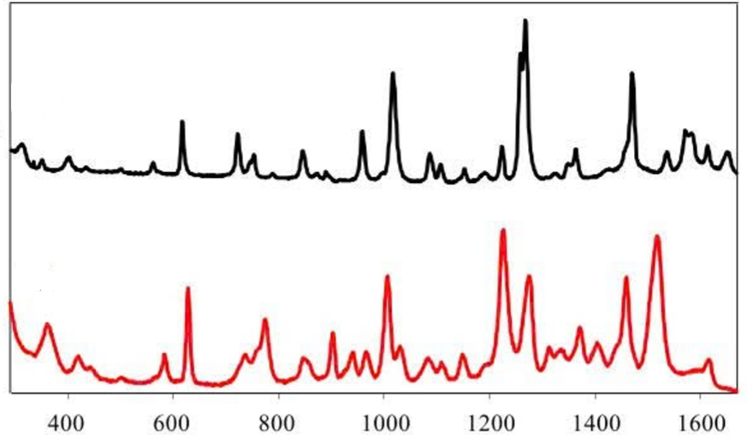

*Figure 47: <https://doi.org/10.1002/jrs.4737>*

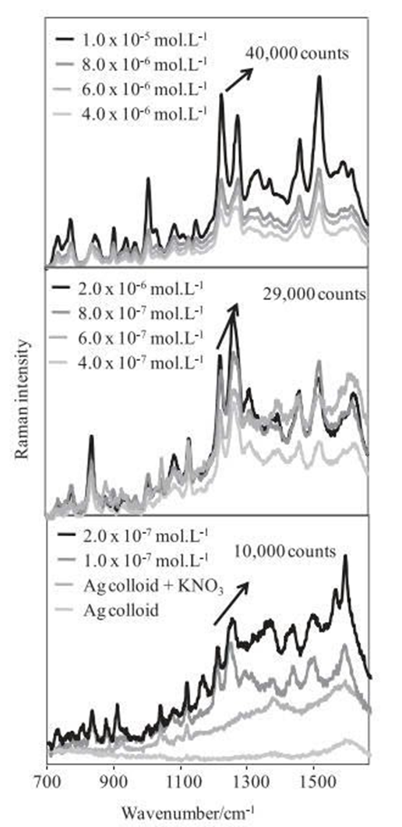

*Figure 48: <https://doi.org/10.1002/jrs.4737>*

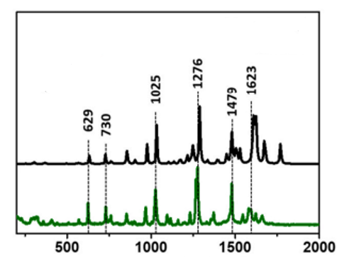

*Figure 49: https://doi.org/10.1016/j.envpol.2022.120775*

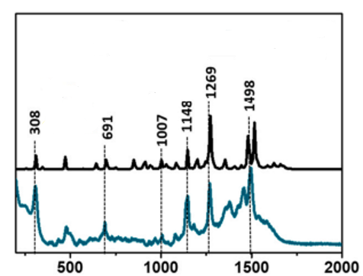

*Figure 50: https://doi.org/10.1016/j.envpol.2022.120775*

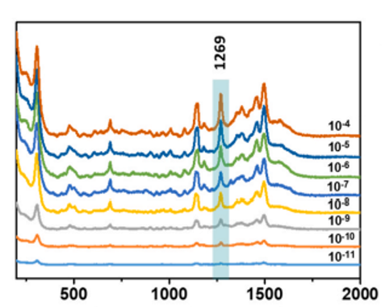

*Figure 51: <https://doi.org/10.1016/j.envpol.2022.120775>*

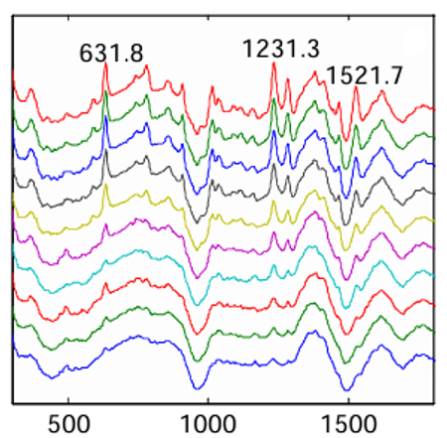

*Figure 52:* *DOI: 10.13031/aim20162460871*

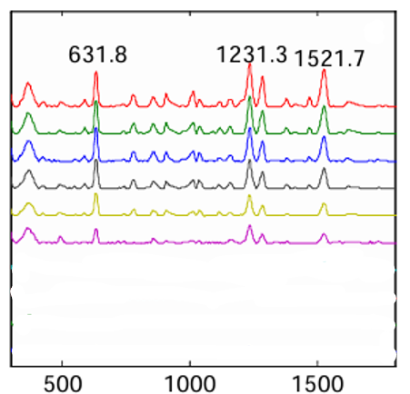

*Figure 53:* *DOI: 10.13031/aim20162460871*

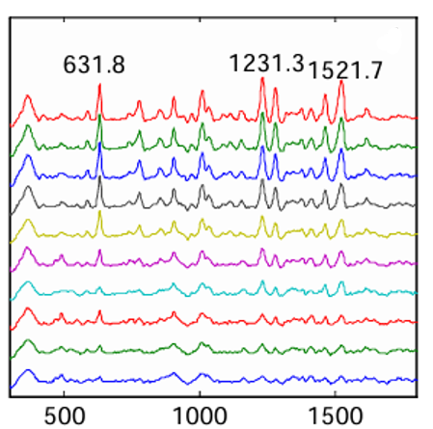

*Figure 54:* *DOI: 10.13031/aim20162460871*

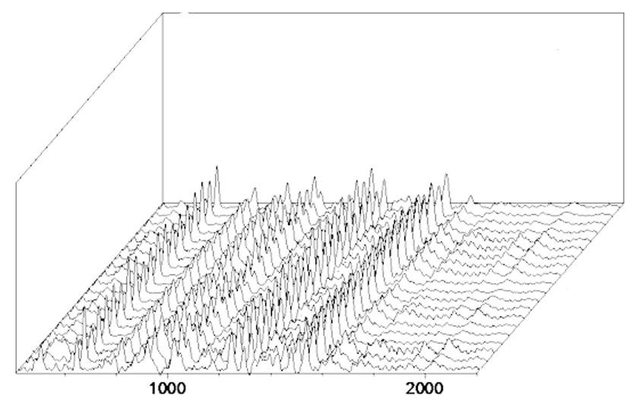

*Figure 55:* *DOI: 10.13031/aim20162460871*

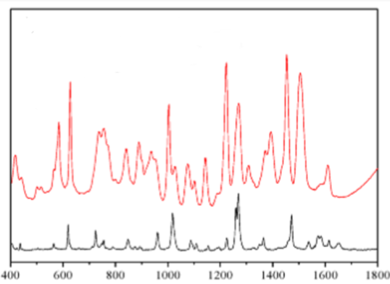

*Figure 56: https://doi.org/10.3390/nano9030355*

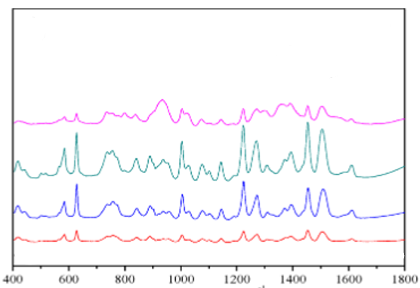

*Figure 57: https://doi.org/10.3390/nano9030355*

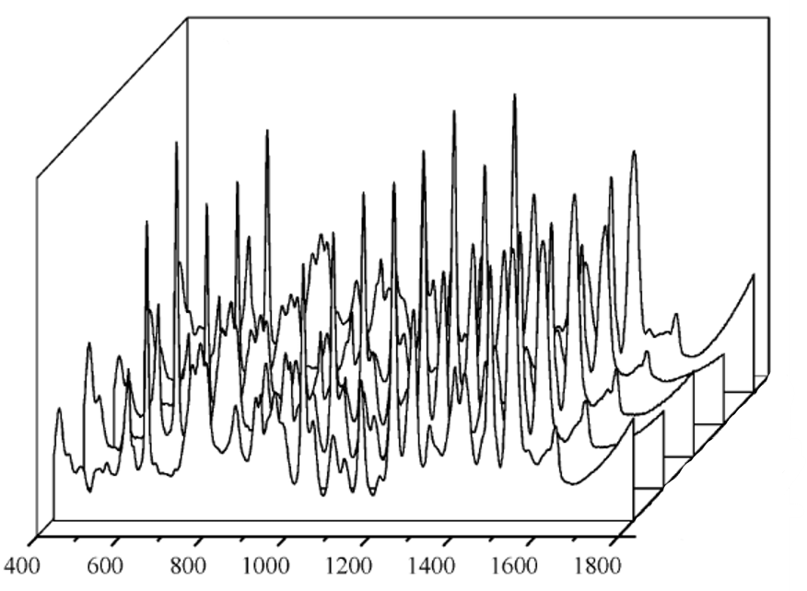

*Figure 58: https://doi.org/10.3390/nano9030355*

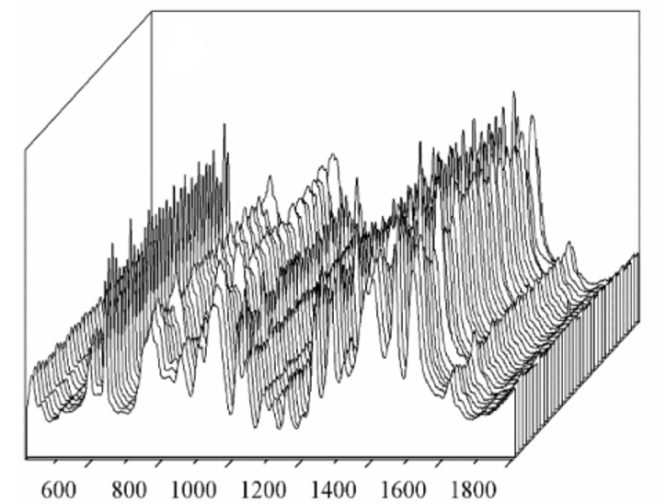

*Figure 59: https://doi.org/10.3390/nano9030355*

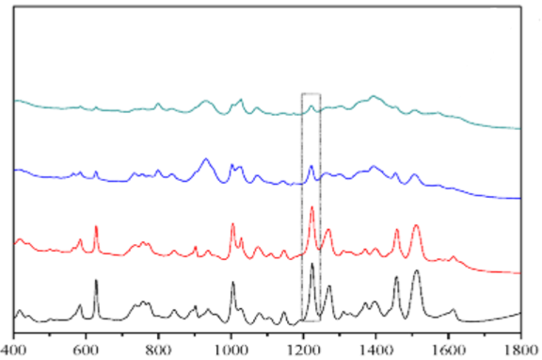

*Figure 60: https://doi.org/10.3390/nano9030355*

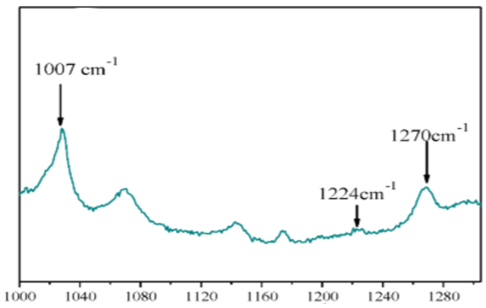

*Figure 61: <https://doi.org/10.3390/nano9030355>*

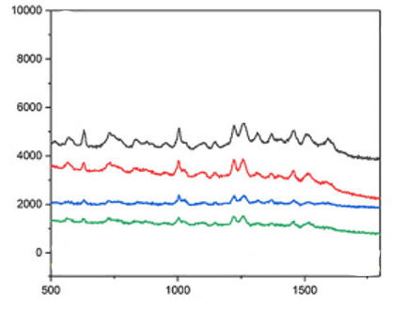

*Figure 62: https://doi.org/10.1016/j.saa.2020.119037*

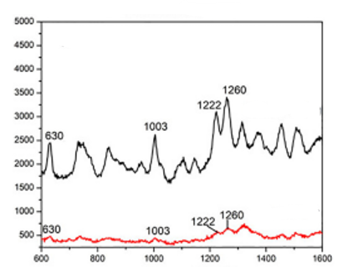

*Figure 63: <https://doi.org/10.1016/j.saa.2020.119037>*

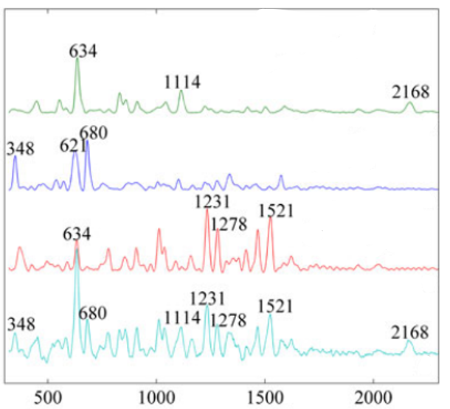

*Figure 64: https://doi.org/10.1002/jrs.5049*

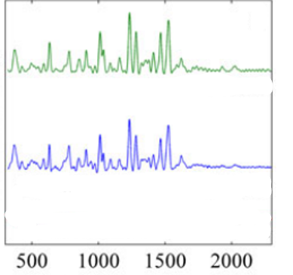

*Figure 65: https://doi.org/10.1002/jrs.5049*

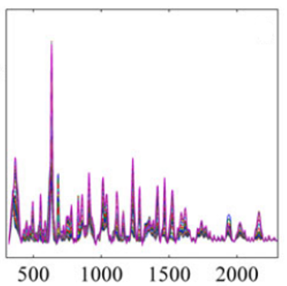

*Figure 66: https://doi.org/10.1002/jrs.5049*

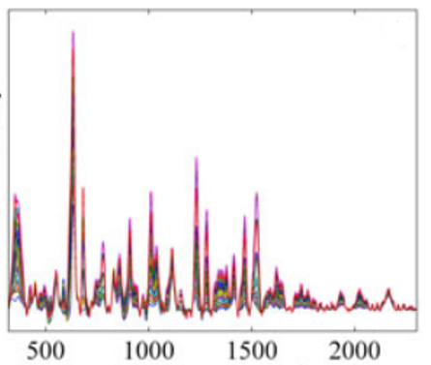

*Figure 67: https://doi.org/10.1002/jrs.5049*

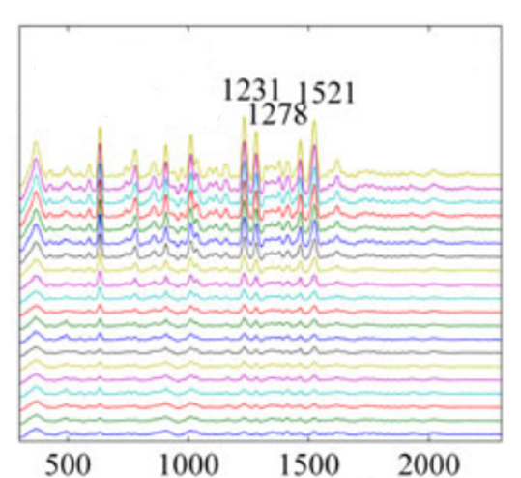

*Figure 68: https://doi.org/10.1002/jrs.5049*

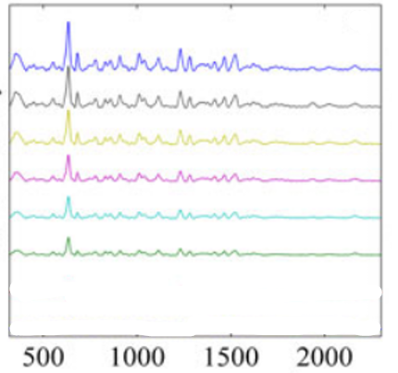

*Figure 69: <https://doi.org/10.1002/jrs.5049>*

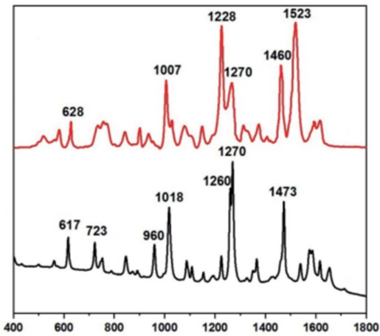

*Figure 70: https://doi.org/10.1039/D1RA09286C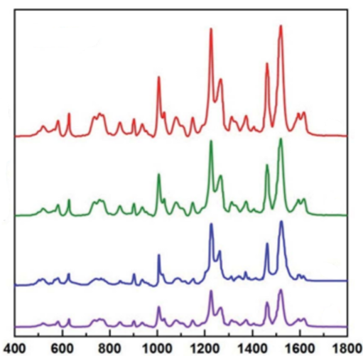*

*Figure 71: https://doi.org/10.1039/D1RA09286C*

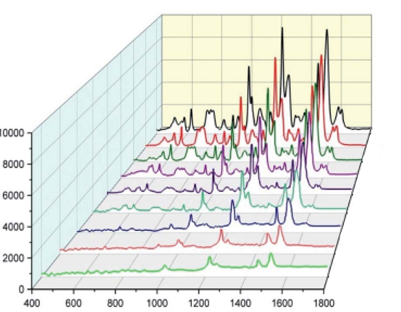

*Figure 72: <https://doi.org/10.1039/D1RA09286C>*

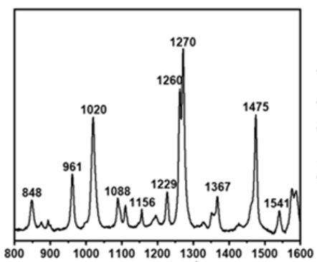

*Figure 73: https://doi.org/10.1021/acsanm.2c03769*

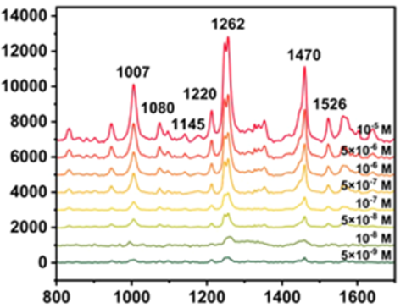

*Figure 74: https://doi.org/10.1021/acsanm.2c03769*

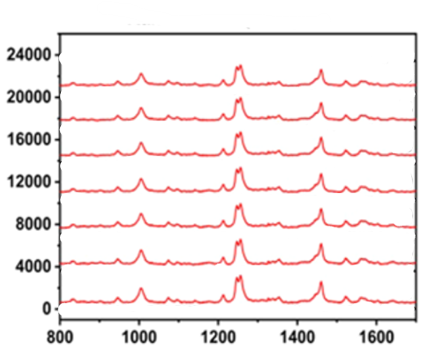

*Figure 75: https://doi.org/10.1021/acsanm.2c03769*

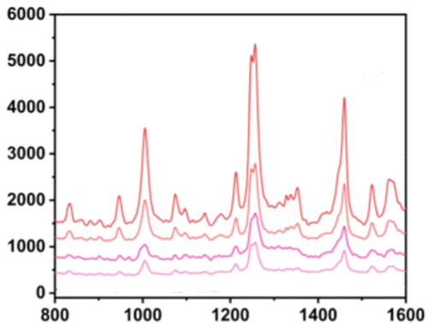

*Figure 76: <https://doi.org/10.1021/acsanm.2c03769>*

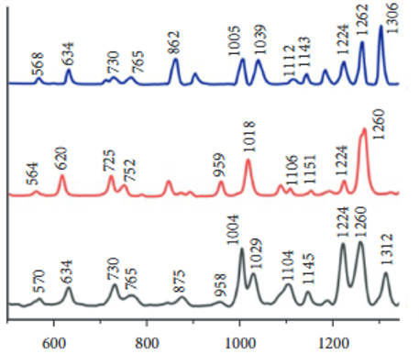

*Figure 77: https://doi.org/10.1155/2022/6947775*

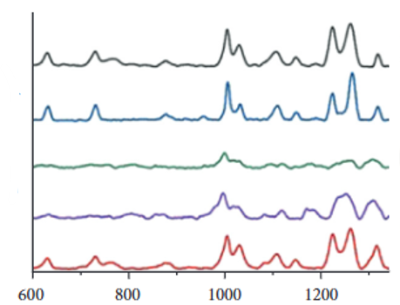

*Figure 78: https://doi.org/10.1155/2022/6947775*

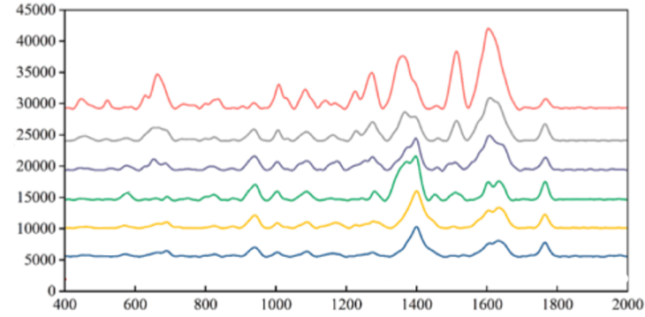

*Figure 79: https://doi.org/10.1016/j.jfca.2025.107854*

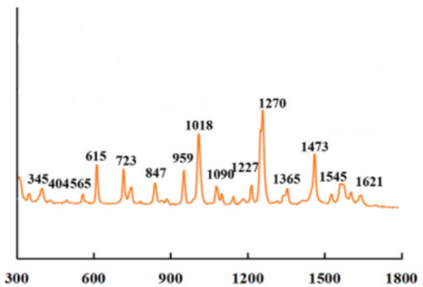

*Figure 80: https://doi.org/10.1016/j.lwt.2022.113804*

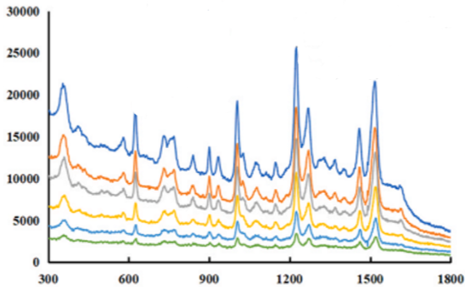

*Figure 81: https://doi.org/10.1016/j.lwt.2022.113804*

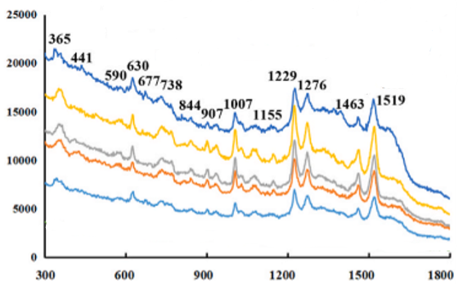

*Figure 82: https://doi.org/10.1016/j.lwt.2022.113804*

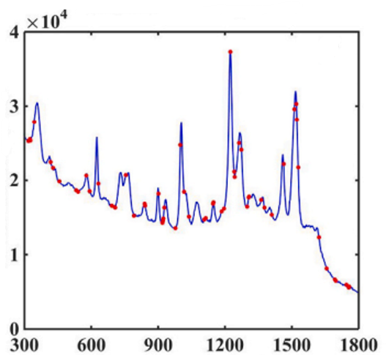

*Figure 83: https://doi.org/10.1016/j.lwt.2022.113804*

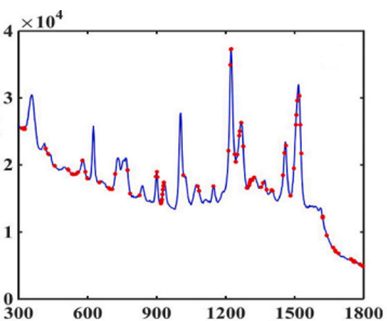

*Figure 84: <https://doi.org/10.1016/j.lwt.2022.113804>*

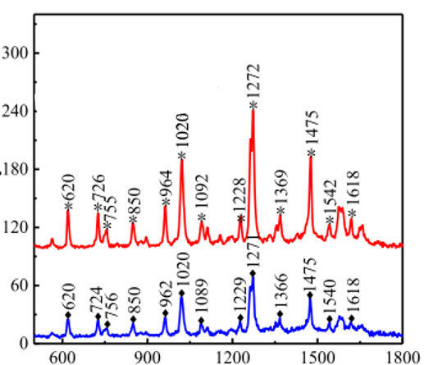

*Figure 85: https://doi.org/10.1016/j.ceramint.2020.08.121*

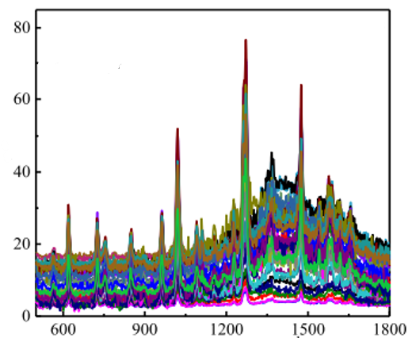

*Figure 86: <https://doi.org/10.1016/j.ceramint.2020.08.121>*

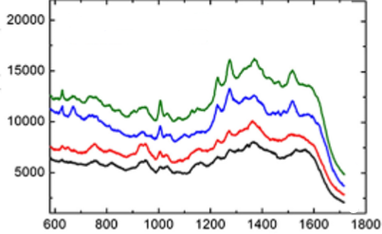

*Figure 87: https://doi.org/10.1007/s11664-019-07662-0*

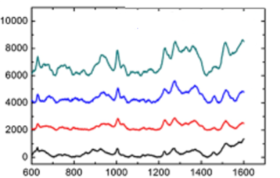

*Figure 88: https://doi.org/10.1007/s11664-019-07662-0*

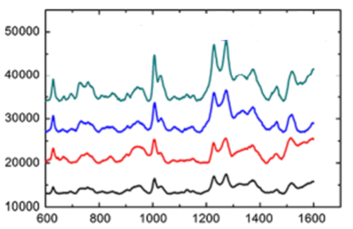

*Figure 89: <https://doi.org/10.1007/s11664-019-07662-0>*

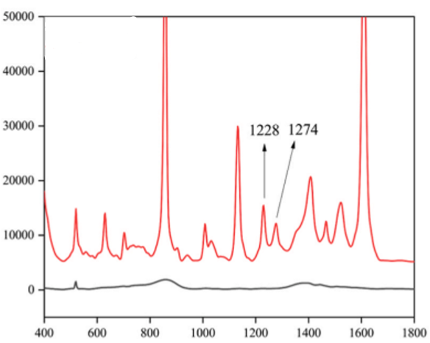

*Figure 90: https://doi.org/10.1016/j.jfca.2024.106461*

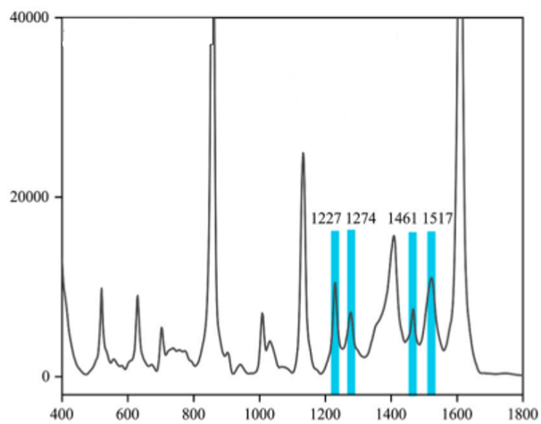

*Figure 91: https://doi.org/10.1016/j.jfca.2024.106461*

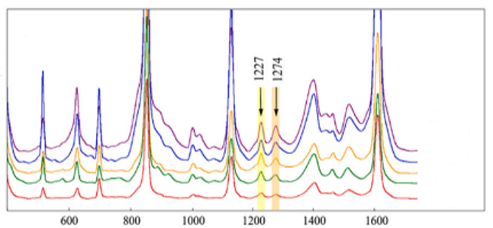

*Figure 92: https://doi.org/10.1016/j.jfca.2024.106461*

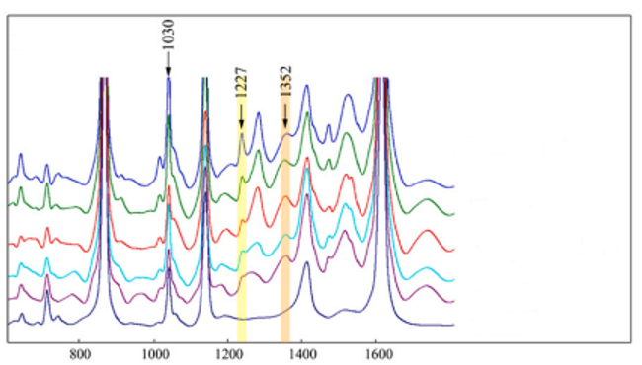

*Figure 93: <https://doi.org/10.1016/j.jfca.2024.106461>*

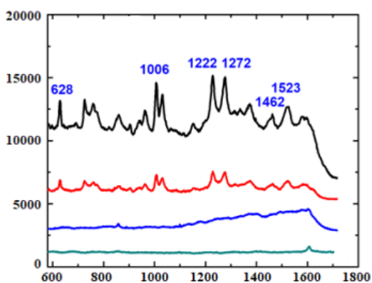

*Figure 94: <https://doi.org/10.25073/2588-1124/vnumap.4765>*

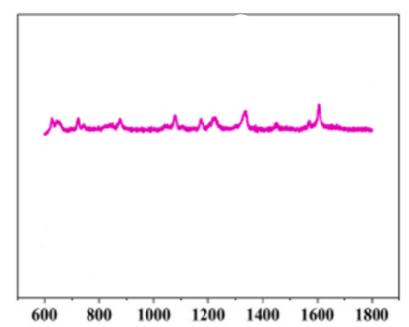

*Figure 95: <https://doi.org/10.1016/j.talanta.2021.122585>*

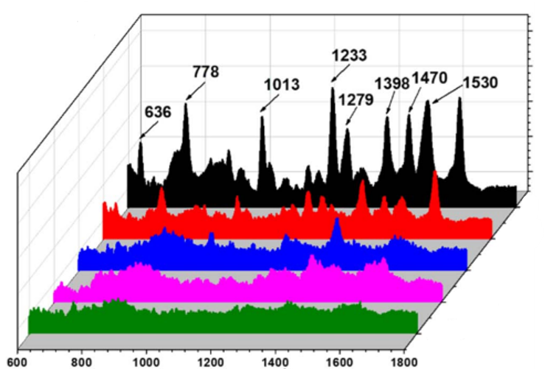

*Figure 96: https://doi.org/10.1039/D5RA00846H*

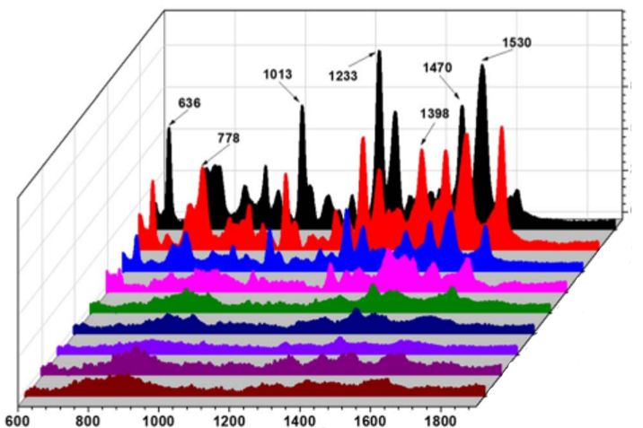

*Figure 97: https://doi.org/10.1039/D5RA00846H*

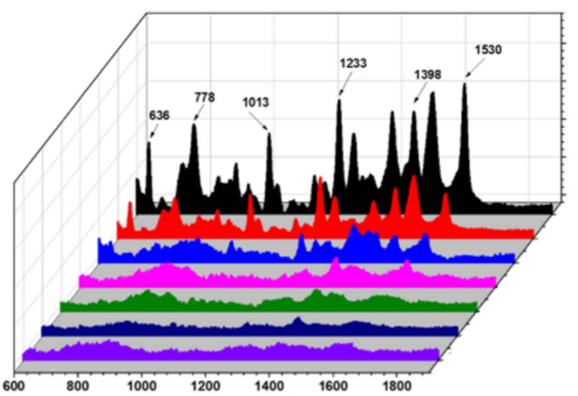

*Figure 98: <https://doi.org/10.1039/D5RA00846H>*

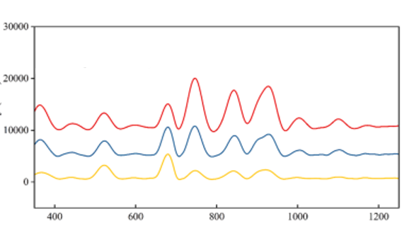

*Figure 99: <https://doi.org/10.1016/j.jfca.2025.107293>*

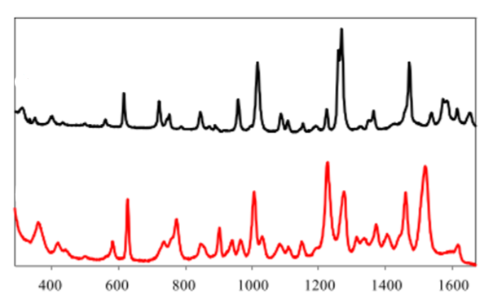

*Figure 100: <https://doi.org/10.1002/jrs.4737>*

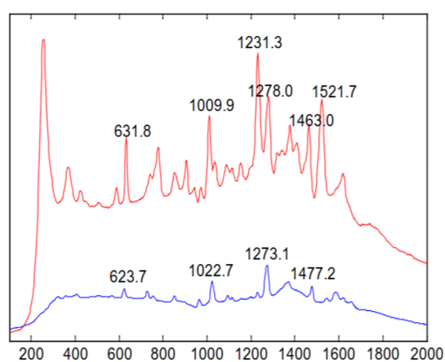

Figure 101: doi:10.13031/aim.20162460871

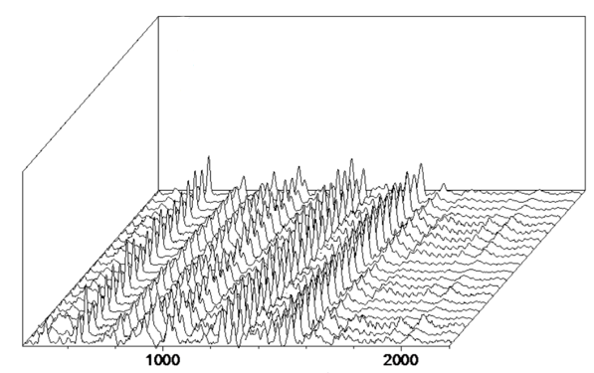

Figure 102: doi:10.13031/aim.20162460871

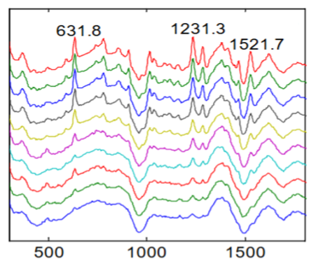

Figure 103 :doi:10.13031/aim.20162460871

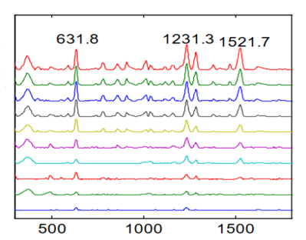

Figure 104: :doi:10.13031/aim.20162460871

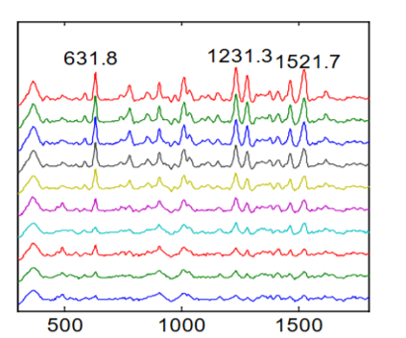

Figure 105: :doi:10.13031/aim.20162460871

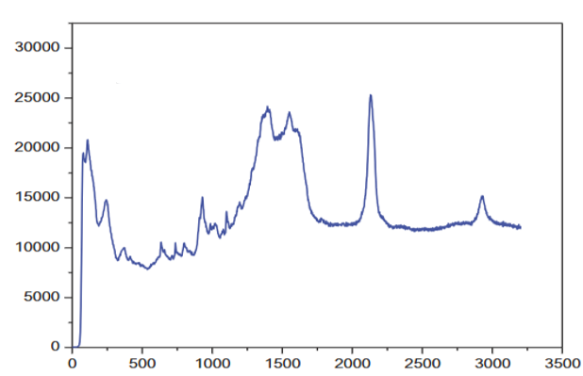

Figure 106: <https://doi.org/10.1080/03067319.2019.1651301>

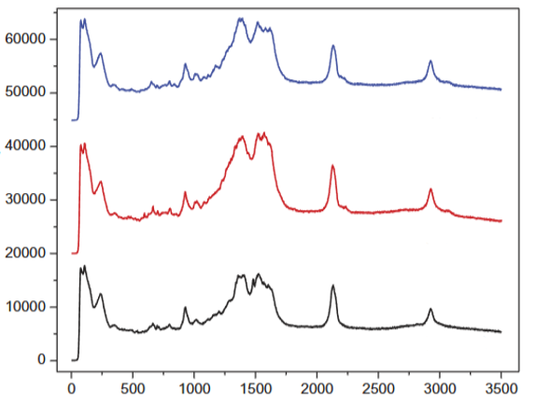

Figure 107: :<https://doi.org/10.1080/03067319.2019.1651301>

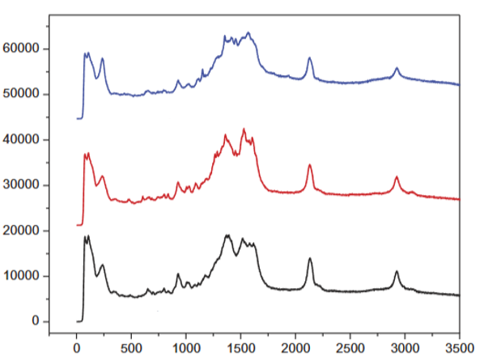

Figure 108: <https://doi.org/10.1080/03067319.2019.1651301>

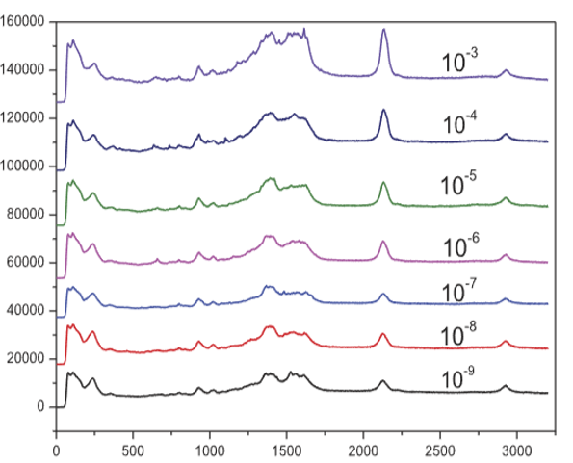

Figure 109: <https://doi.org/10.1080/03067319.2019.1651301>

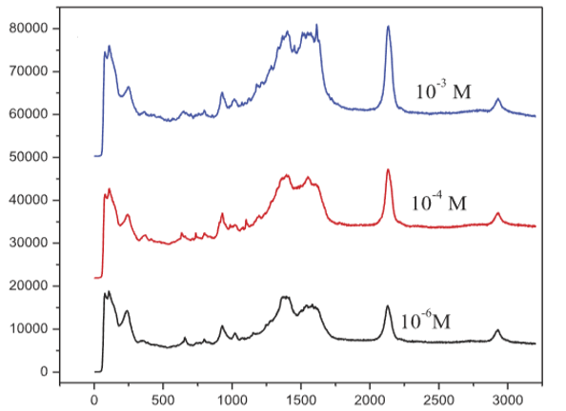

Figure 110: <https://doi.org/10.1080/03067319.2019.1651301>

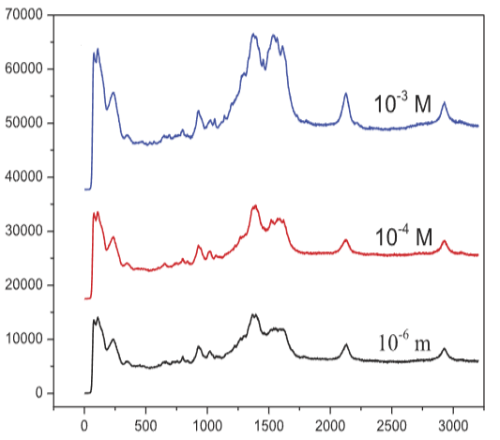

Figure 111: <https://doi.org/10.1080/03067319.2019.1651301>

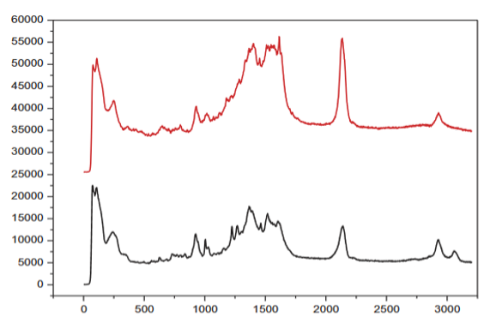

Figure 112: <https://doi.org/10.1080/03067319.2019.1651301>

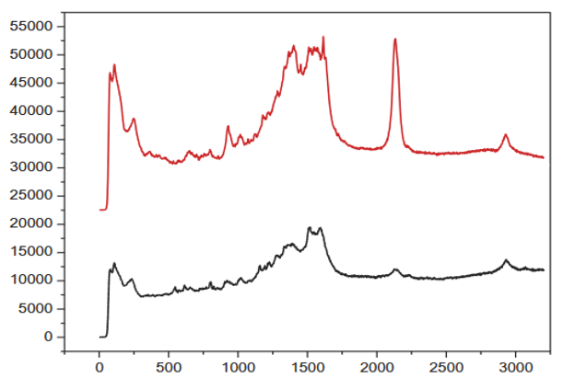

Figure 113: <https://doi.org/10.1080/03067319.2019.1651301>

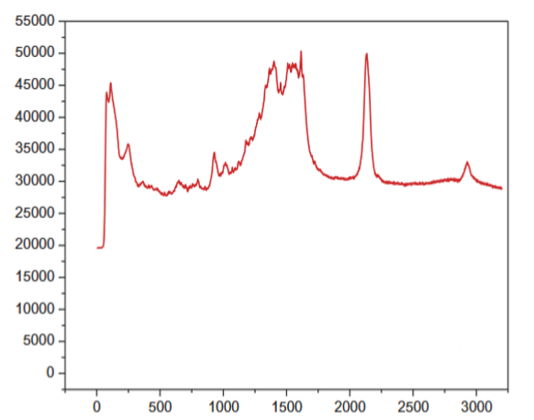

Figure 114: <https://doi.org/10.1080/03067319.2019.1651301>

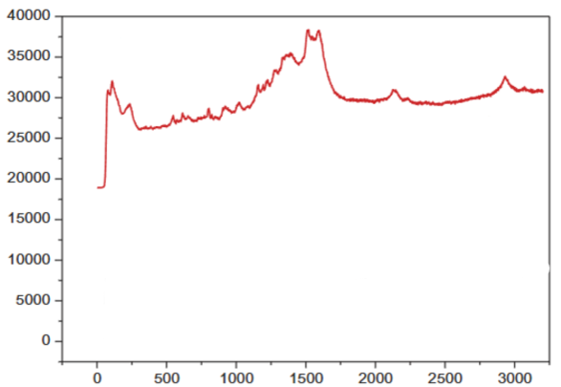

Figure 115: <https://doi.org/10.1080/03067319.2019.1651301>

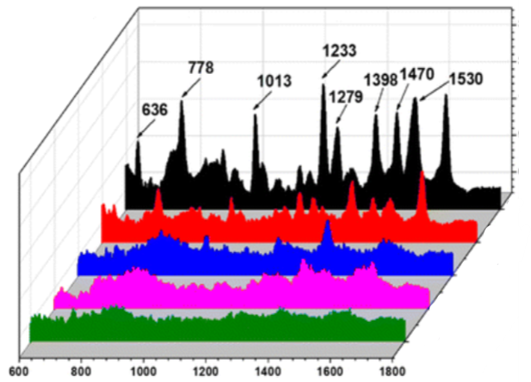

Figure 116 :[10.1039/D5RA00846H](https://doi.org/10.1039/D5RA00846H)

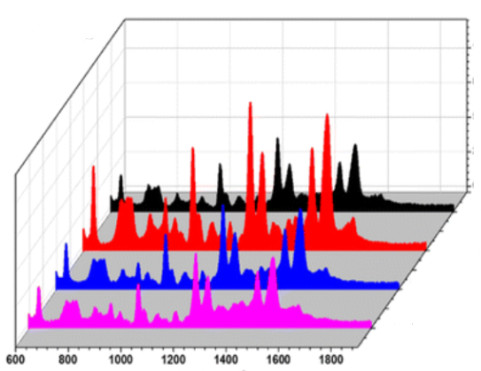

Figure 117: [10.1039/D5RA00846H](https://doi.org/10.1039/D5RA00846H)

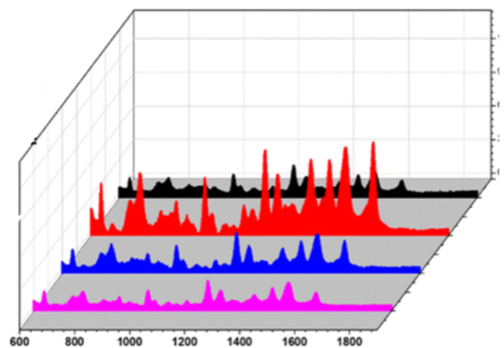

Figure 118: [10.1039/D5RA00846H](https://doi.org/10.1039/D5RA00846H)

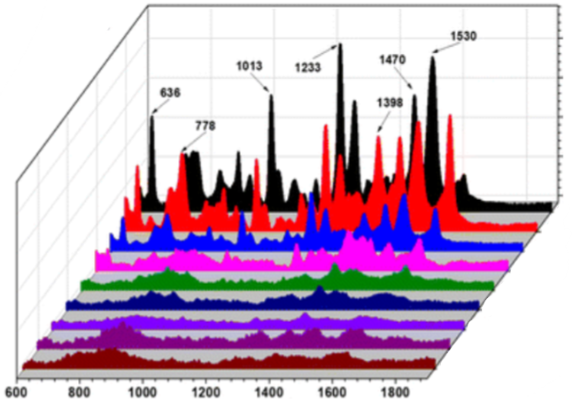

Figure 119: [10.1039/D5RA00846H](https://doi.org/10.1039/D5RA00846H)

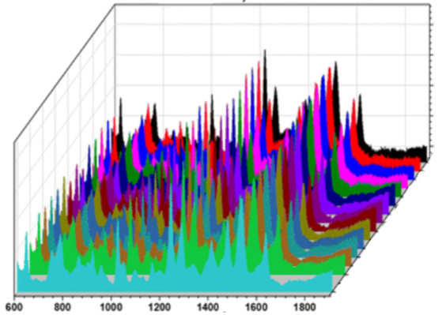

Figure 120: [10.1039/D5RA00846H](https://doi.org/10.1039/D5RA00846H)

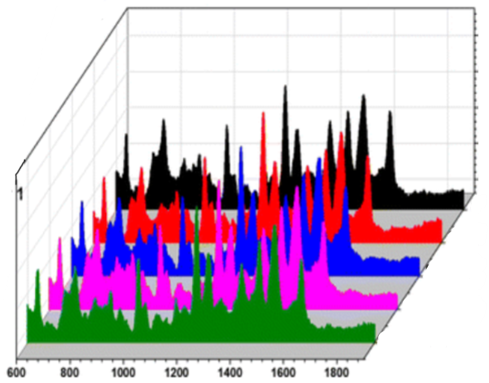

Figure 121: [10.1039/D5RA00846H](https://doi.org/10.1039/D5RA00846H)

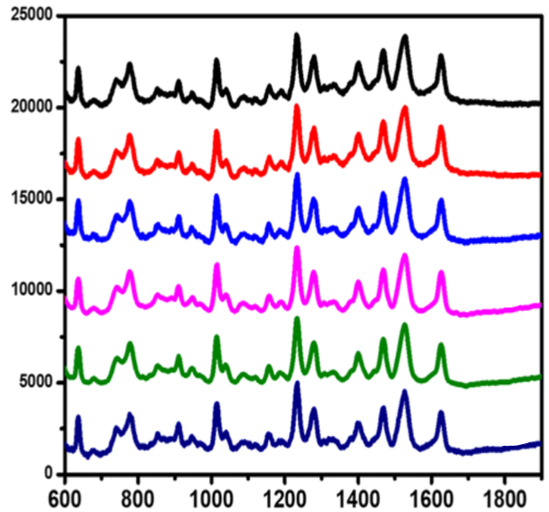

Figure 122: [10.1039/D5RA00846H](https://doi.org/10.1039/D5RA00846H)

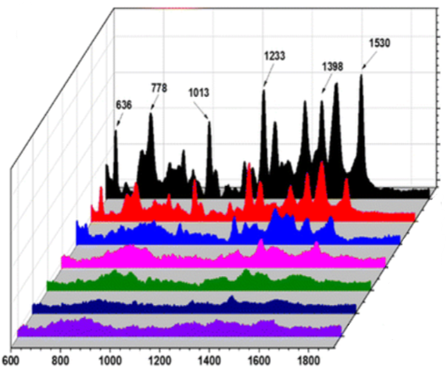

Figure 123: [10.1039/D5RA00846H](https://doi.org/10.1039/D5RA00846H)

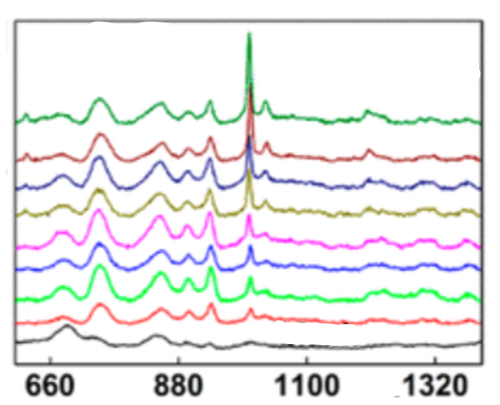

Figure 124: <https://doi.org/10.1002/pssa.202100412>

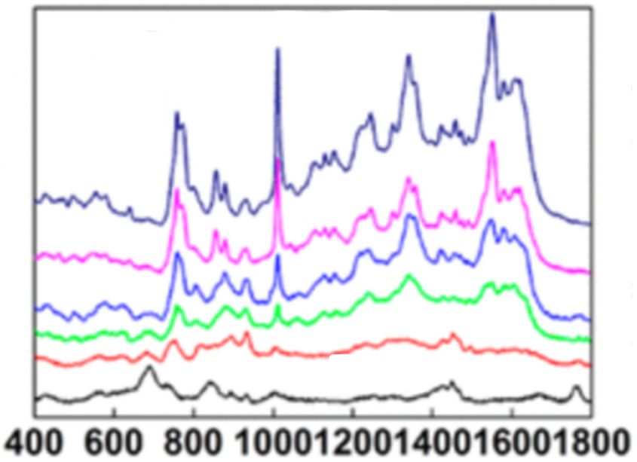

Figure 125 : <https://doi.org/10.1002/pssa.202100412>

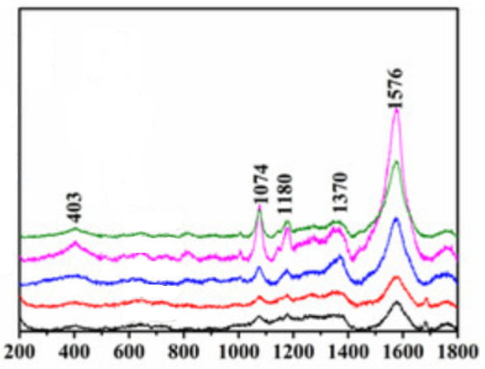

Figure 126: **<https://doi.org/10.3390/molecules29102383>**

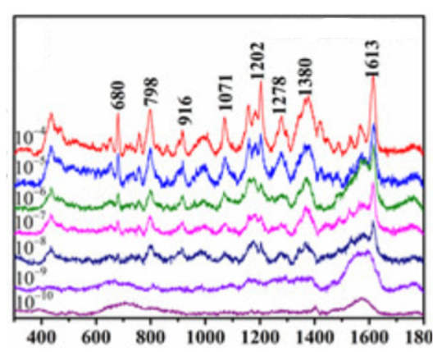

Figure 127: **<https://doi.org/10.3390/molecules29102383>**

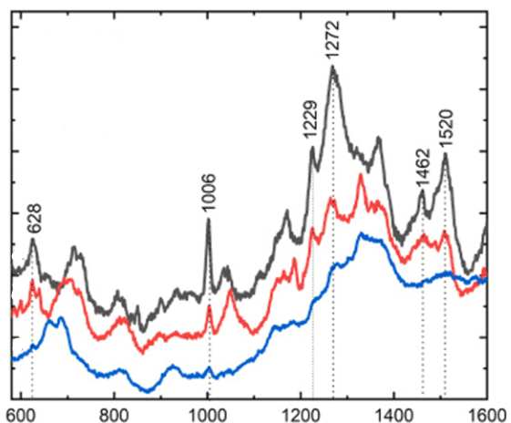

Figure 128: <https://doi.org/10.1016/j.omx.2023.100250>

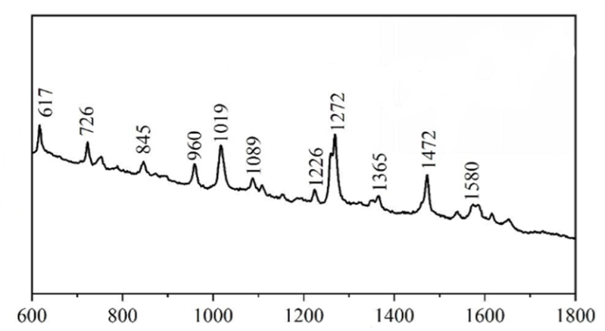

Figure 129: <https://doi.org/10.1021/acsanm.4c07158>

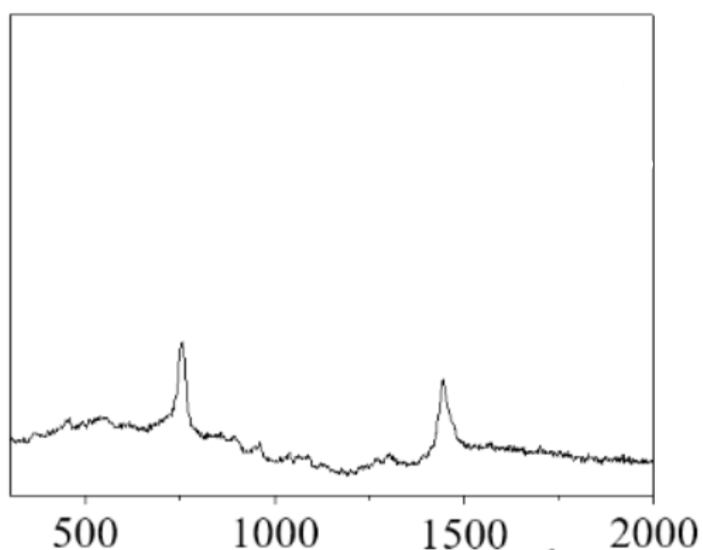

Figure 130: <https://doi.org/10.1021/acsanm.4c06045>

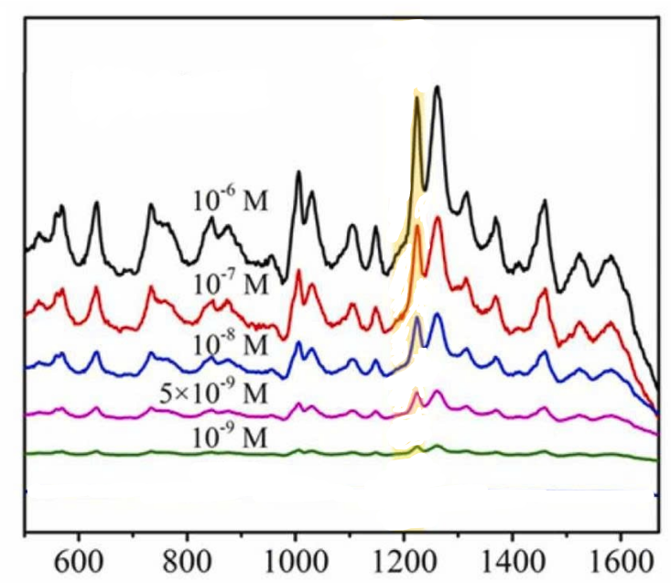

Figure 131: <https://doi.org/10.1016/j.snb.2021.131250>

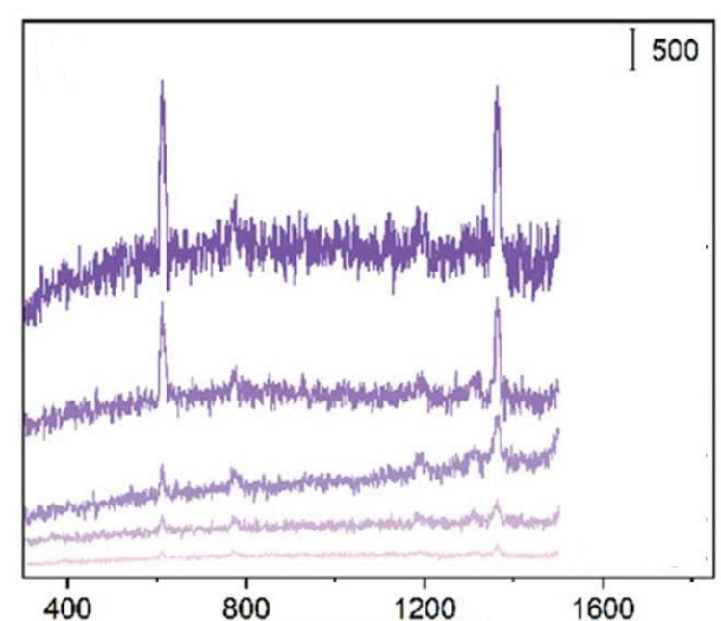

Figure 132: <https://doi.org/10.1002/admt.202300367>

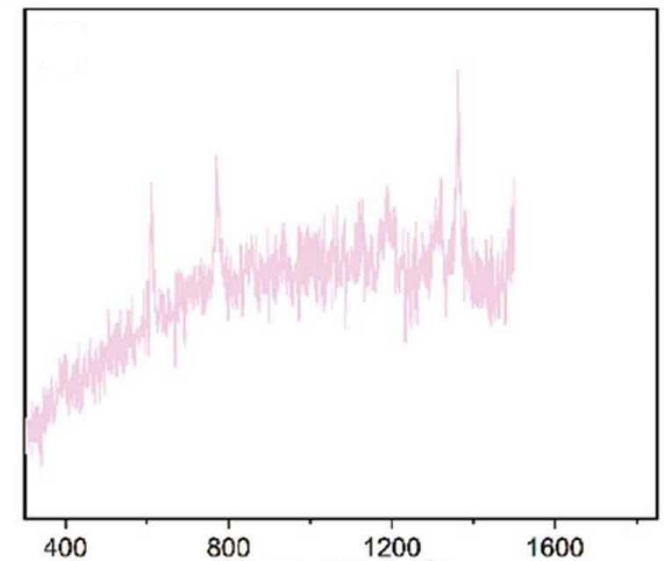

Figure 133: <https://doi.org/10.1002/admt.202300367>

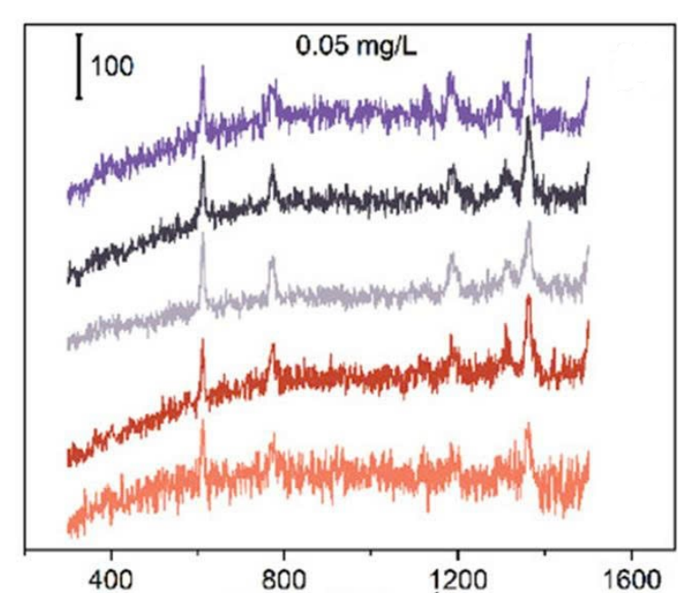

Figure 134: <https://doi.org/10.1002/admt.202300367>

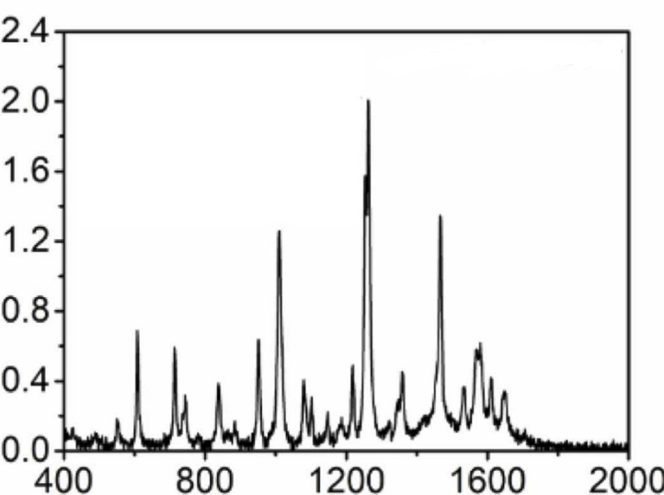

Figure 135: <https://doi.org/10.1016/j.jfca.2024.106564>

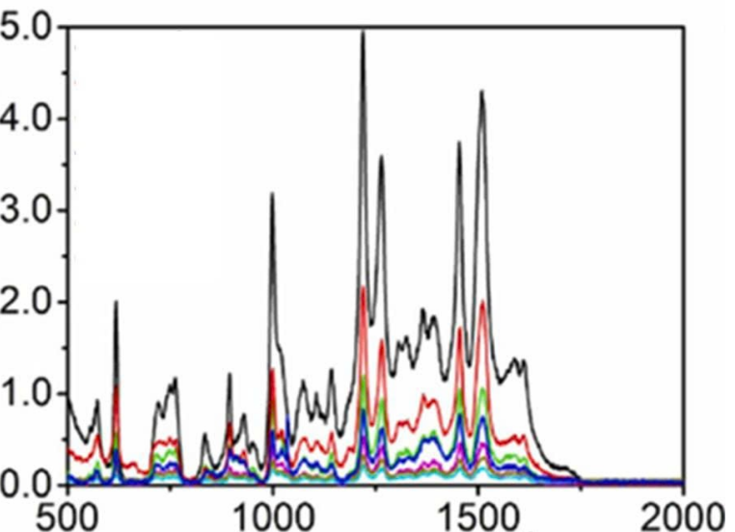

Figure 136: <https://doi.org/10.1016/j.jfca.2024.106564>

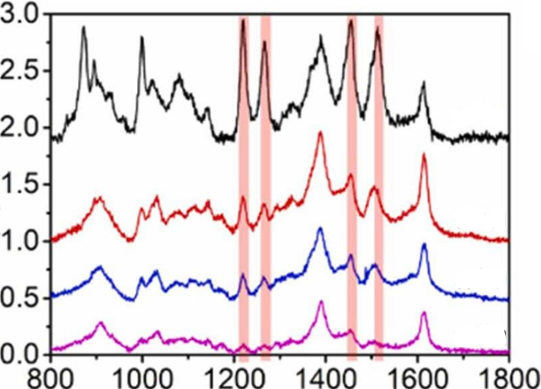

Figure 137: <https://doi.org/10.1016/j.jfca.2024.106564>